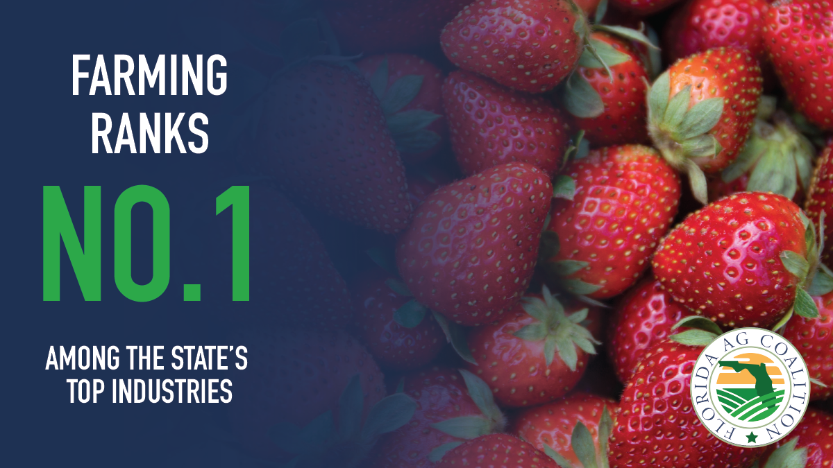

Florida agriculture is among one of the top industries in the state. As a key element of our state’s economy, it is crucial to continue to support our Florida farmers, ranchers and growers.

