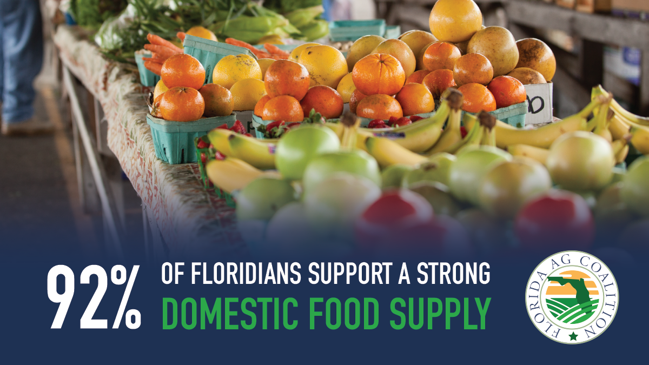

In a poll conducted this spring, Florida voters shared their overwhelming support of Florida farmers. Since the COVID-19 pandemic, it has become increasingly clear to Floridians the value of our strong domestic food supply.

