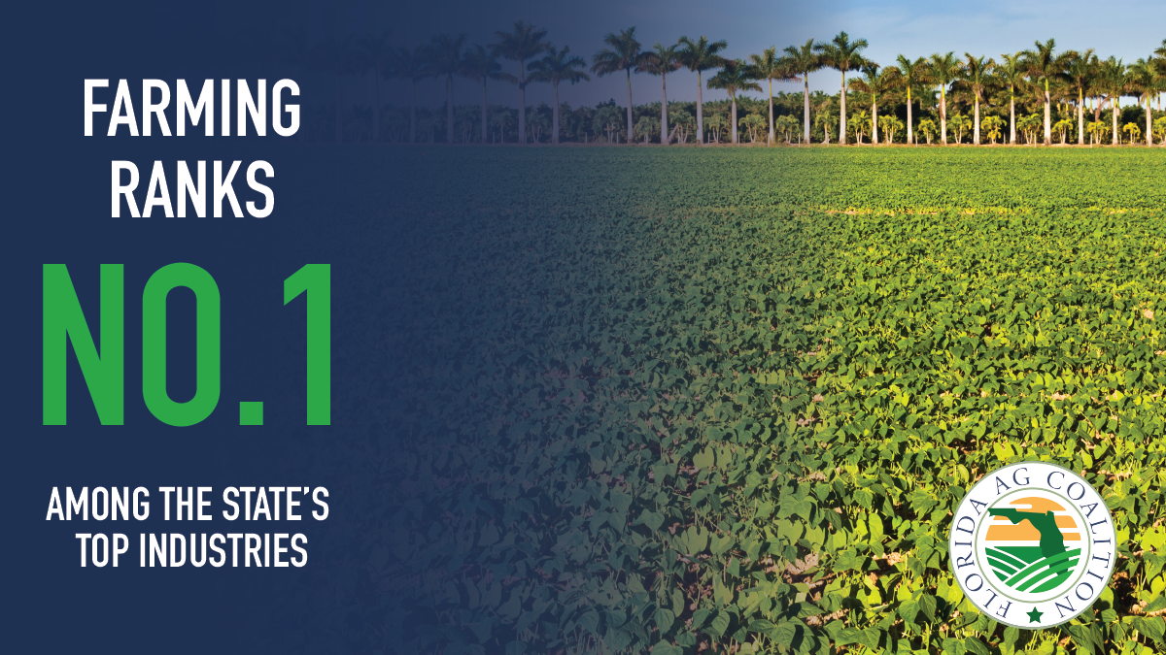

Florida is the nation’s salad bowl during the winter months. Our Florida farmers work hard feed the families that depend on us during the colder season.

